Accessible PDF

How To Add Headings

Open A Microsoft Word Document and select the Styles Pane
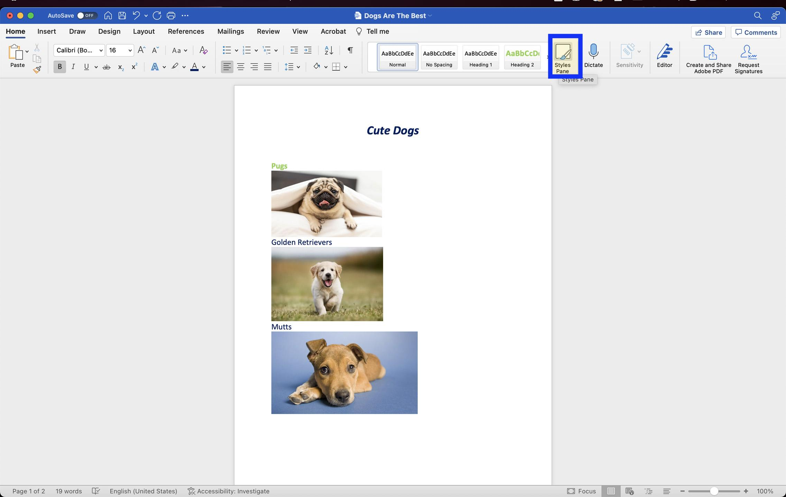
Select All Styles
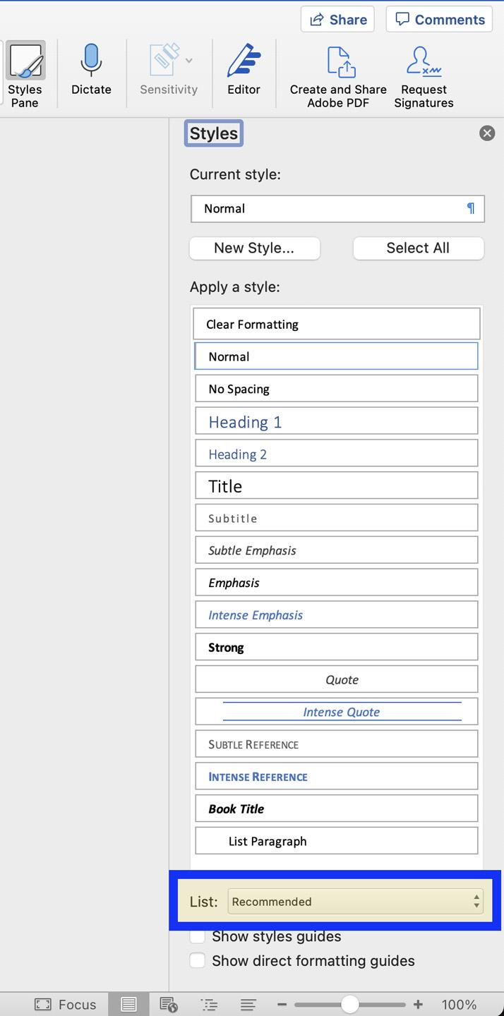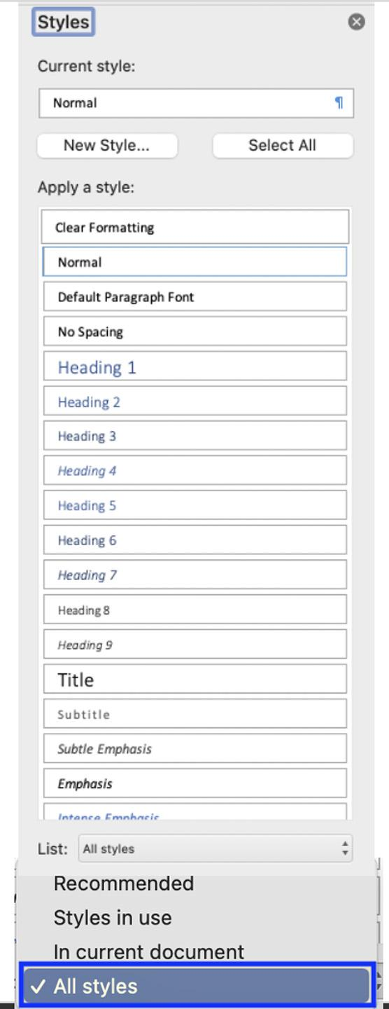
Highlight the title of the document and control click (Mac) or right click (Windows) select “Heading 1”
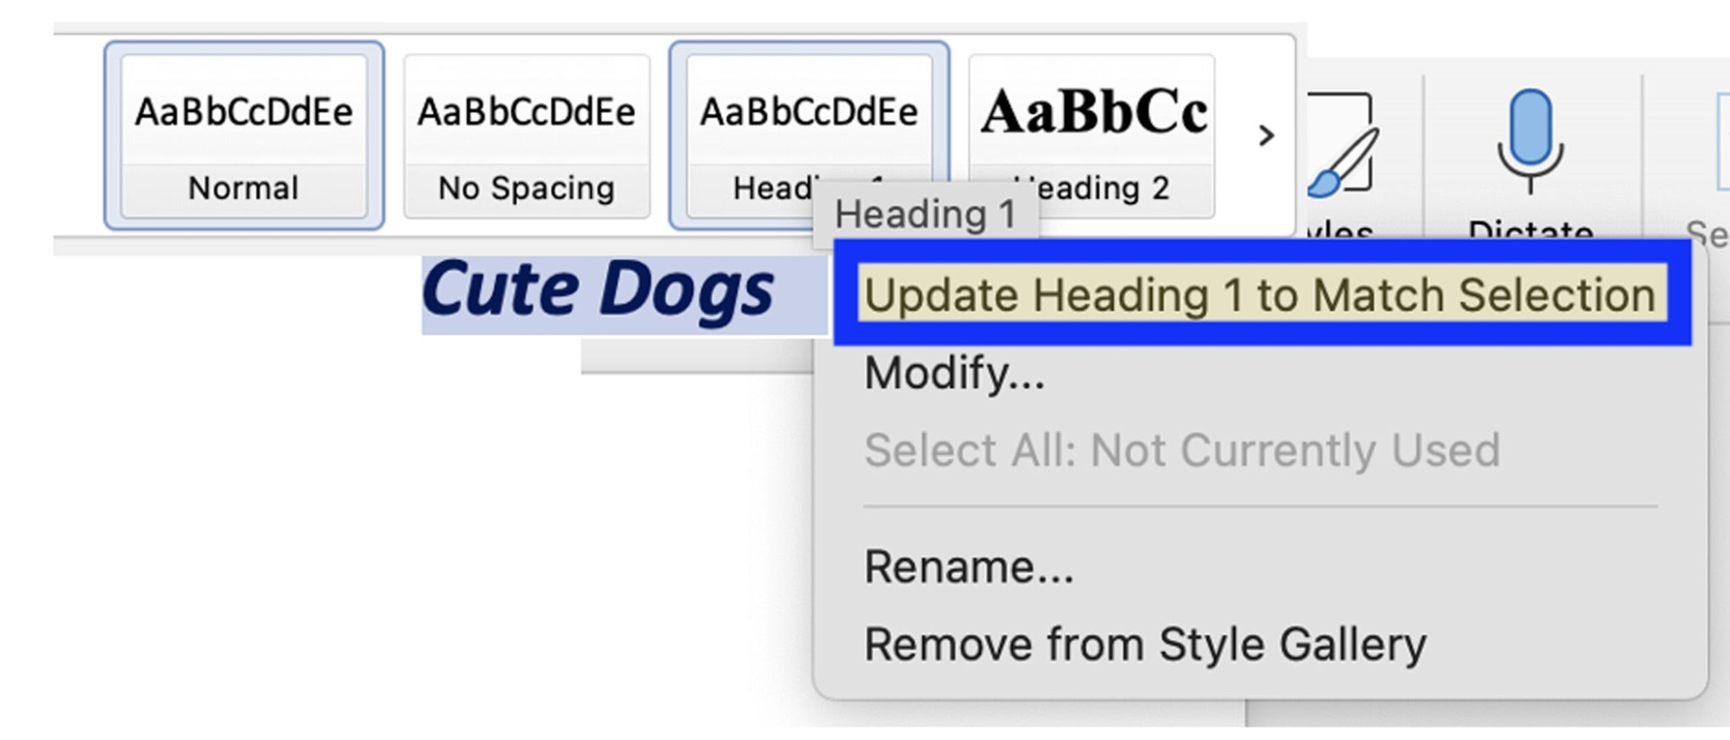
Additional headings in the document should be tagged. When a heading is updated the style choices like color, bolding, italics or underlining can easily be transferred to the next heading.
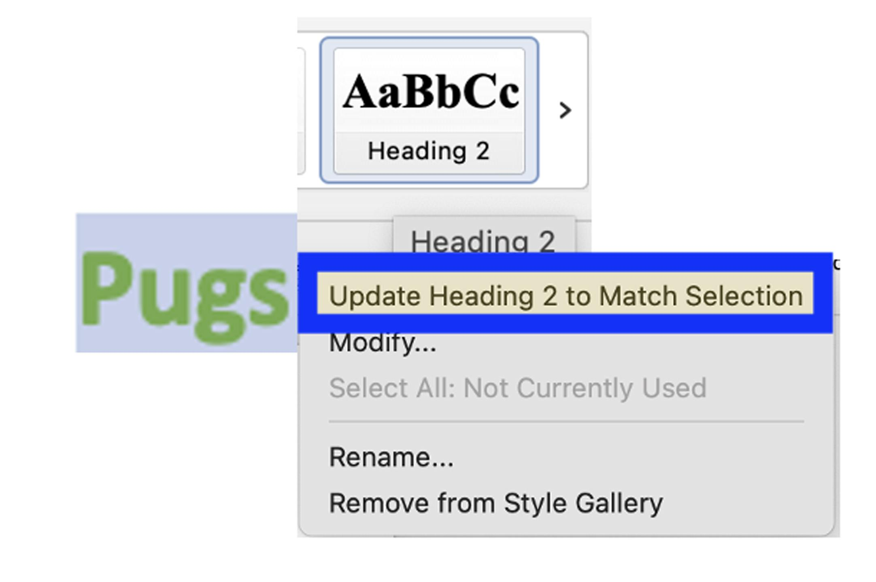
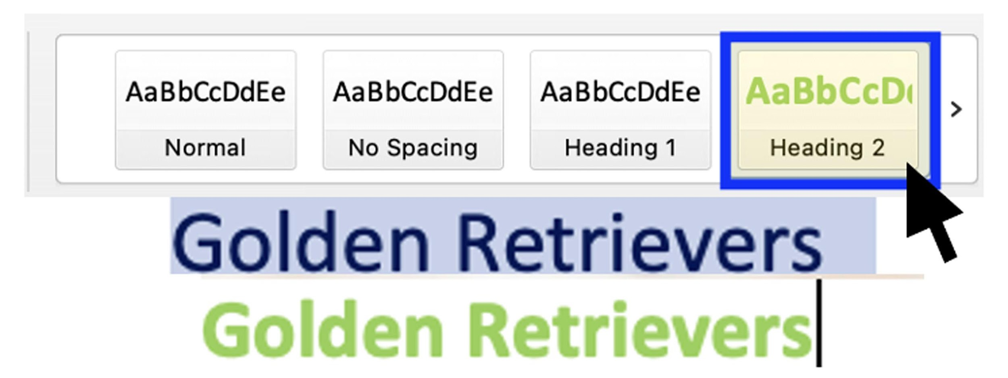

Use about 3-4 heading levels maximum. And make sure they follow a logical order.
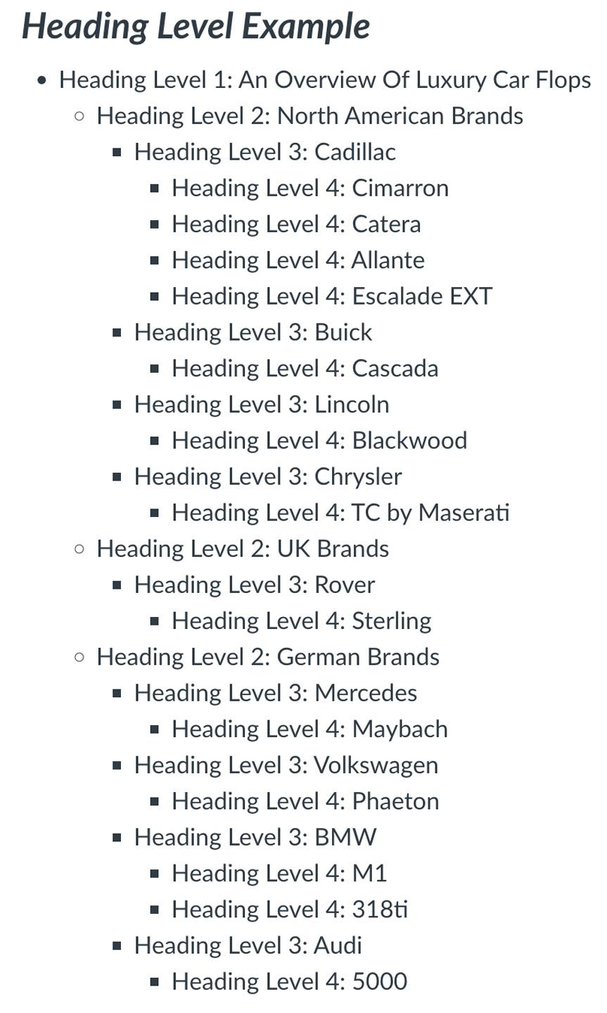

Microsoft Accessibility Checker

Go to Tools and select Check Accessibility to open the checker
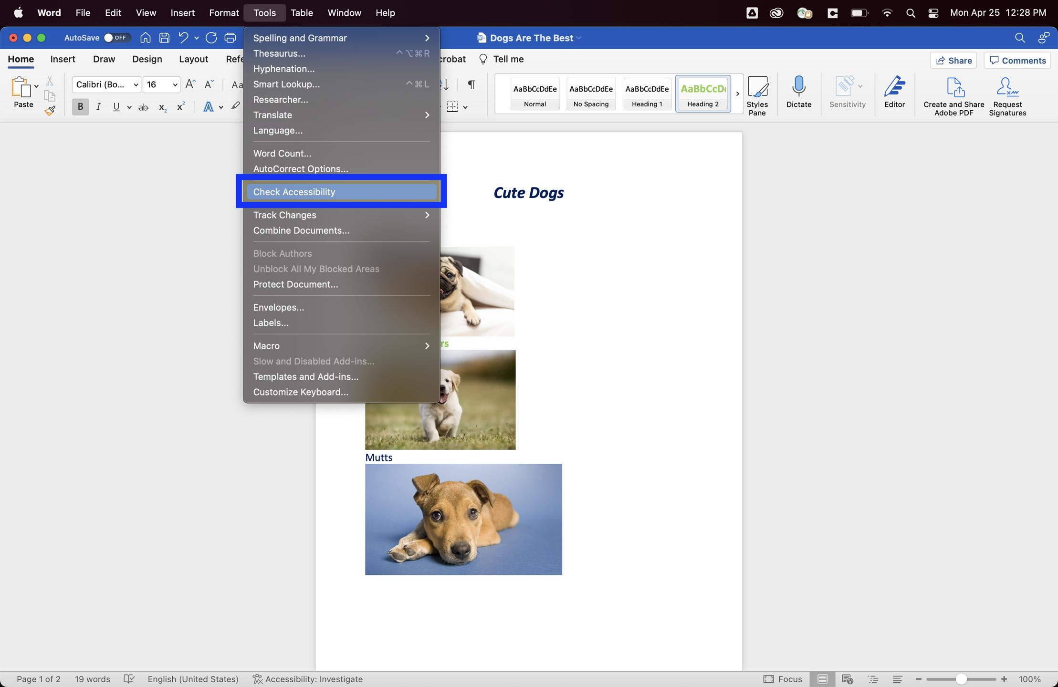
The Accessibility checker shows any errors or potential accessibility barriers and provides steps on how to fix them.
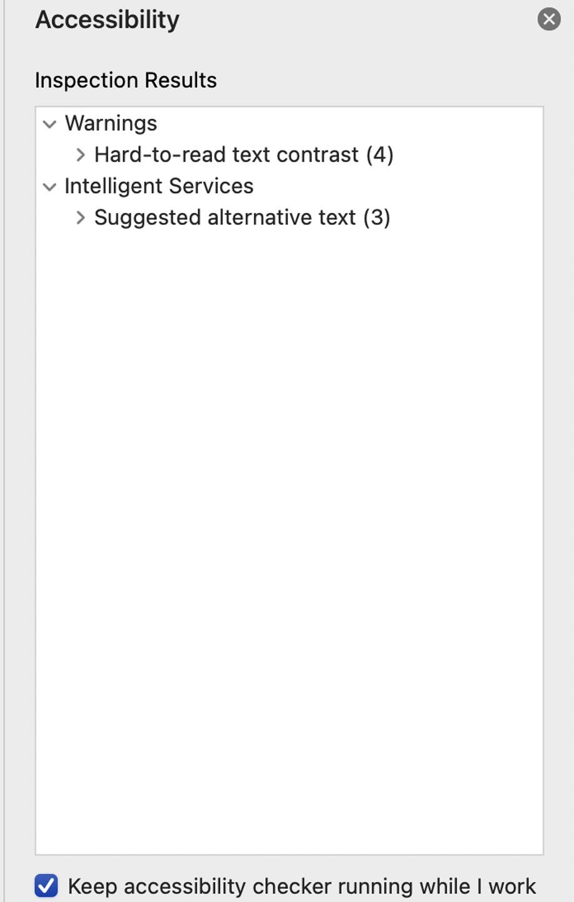 Dialogue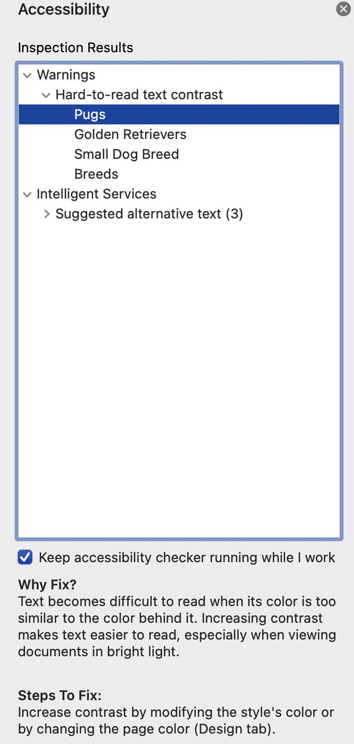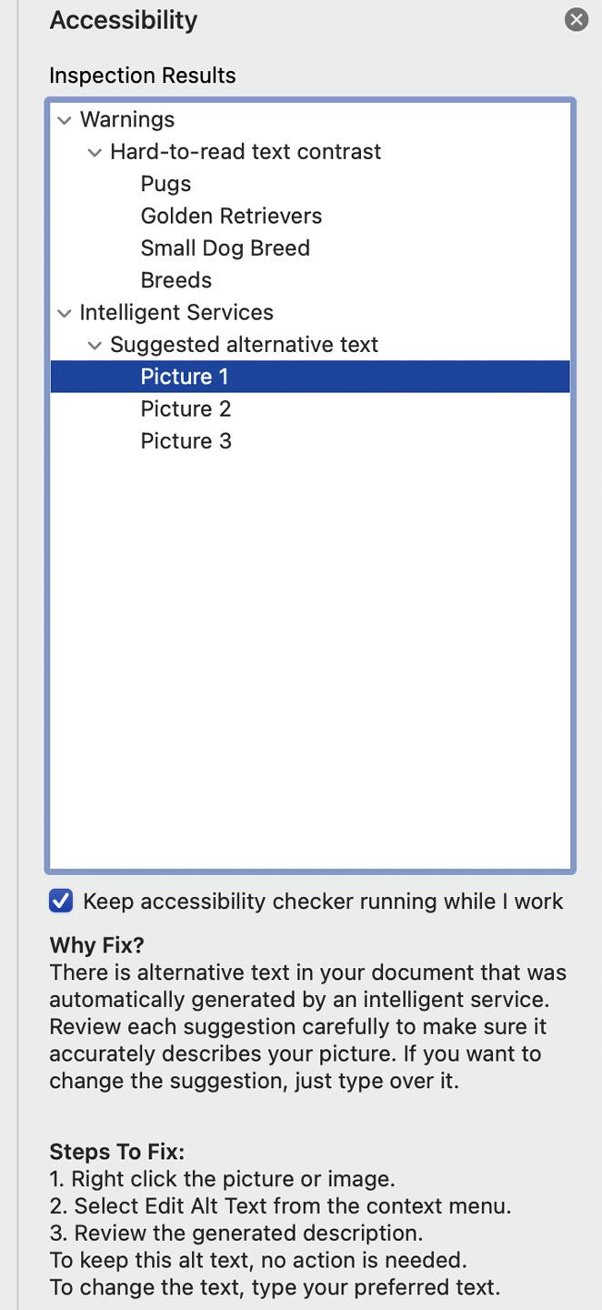

As they are remediated the errors disappear.
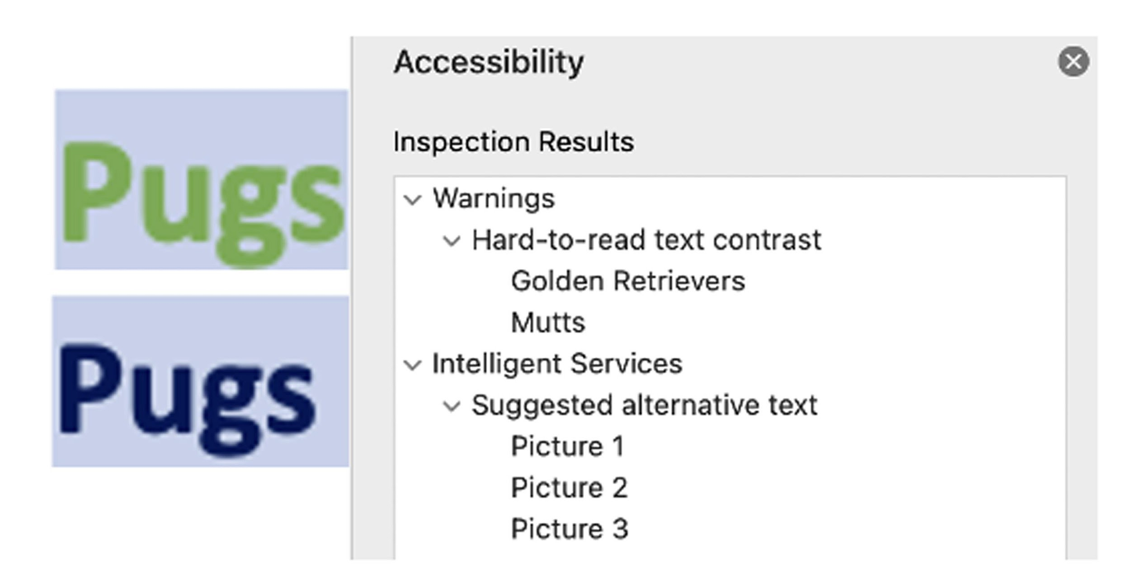

Alt text can be added to images by right clicking (Windows) or control click (Mac). Don’t use words like image in the description because the screen reader will announce that it is an image. Describe the picture succinctly and limit the description to 125 characters max. 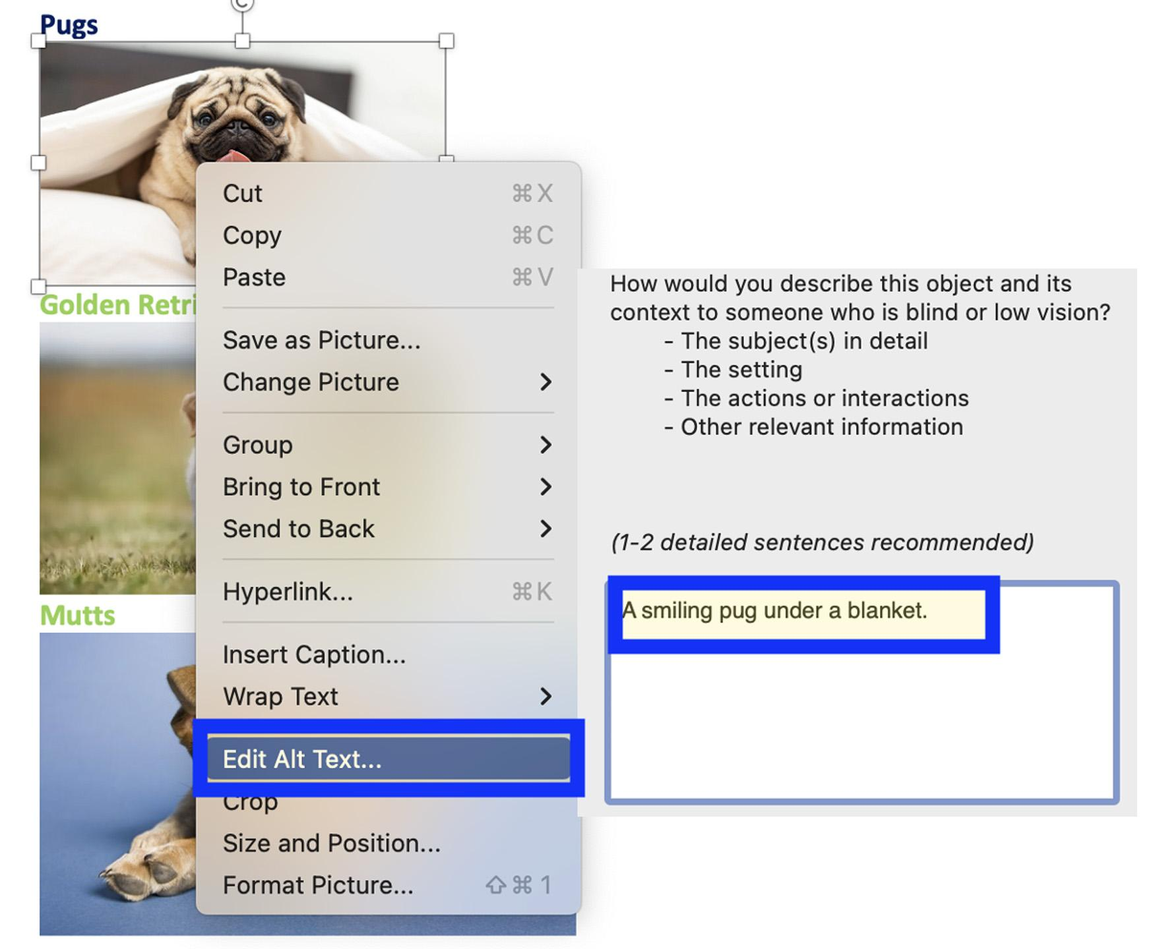

Exporting A PDF

When all the accessibility errors have been corrected it is time to export the document as a PDF. Make sure to choose best for electronic distribution and accessibility.
