A Data Risk Assessment addresses security, privacy, and legal risks posed to the University. A Data Risk Assessment is required for Stanford projects that involve any of the following:
- High Risk or Moderate Risk Data
- Use of solutions other than Stanford Approved Services
- Involvement of a new entity that will handle Moderate or High Risk Stanford Data

HOW TO INITIATE A DATA RISK ASSESSMENT:
- Review the Stanford Risk Classifications and the Data Risk Assessment process before completing the intake form.

- Complete the intake form as follows:
  - Sections A and B must be completed by a Stanford individual who has full programmatic knowledge of the project. Questions about these sections should be sent to privacy@stanford.edu.
  - Section C will require consultation with information security and the technical staff involved in the project who will administer the systems. This section may require detailed technical information from your outside collaborator(s). Provide the form to them as soon as possible to allow sufficient time for completion. Questions about this section should be sent to iso-consulting@lists.stanford.edu.
  - Completely answer ALL questions and specify “N/A” if a question does not apply to your project. Leaving any questions unanswered may delay the review process.
- Once your intake form is completed and you have gathered all supporting documents, file a ServiceNow ticket as follows:
  - Log into stanford.service-now.com and select ‘Information Technology’.
  - Select ‘Request Something’, category “Security and Compliance,” and Request Type ‘Privacy and Security Review – General Request’.

- Attach your completed intake form, data flow diagram, related agreements and, if applicable, your IRB application to the ServiceNow ticket. Review may be delayed if these documents are not attached. An application is considered complete only when the form is complete and all documents are attached.

AFTER YOU SUBMIT YOUR COMPLETED APPLICATION:

After receiving your intake form and all supporting documents, your information will be reviewed. If more information or clarification is needed, your technical and programmatic staff and those of your collaborator(s) may be scheduled for a meeting. A report will be issued with recommendations for addressing the risks posed by the project.

QUESTIONS:

General questions about the form or process can be directed to privacy@stanford.edu. Thank you, and we look forward to collaborating with you on this project.
STANFORD APPLICANT
SUBMITTER NAME AND TITLE
John Doe, Director of Managers
IF NOT SAME AS ABOVE, PROJECT LEAD NAME AND TITLE

DEPARTMENT
UIT Communications
PHONE NUMBER  650-555-5555 | EMAIL  jdoe@stanford.edu
PROJECT TITLE
Infiniti and Beyond
TYPE OF PROJECT
☐ Medical/Clinical Care ☐ Student education ☐ Quality improvement/assessment
☐ Research ☐ Fundraising/marketing ☐ University administration/operations
☒ Outsourcing (process, application/service) ☐ Other (describe):
IRB PROTOCOL NUMBER (if applicable)
Not Applicable

Please review Stanford’s Risk Classification Guide before answering the next portion.

- INFORMATION ABOUT THE PROJECT

- Overview.
- Identify all non-Stanford parties involved in the project.
Third party/Organization name | Role  (e.g., vendor, funding sponsor, business associate, subcontractor, collaborator, technical support, etc.) | Point of Contact | Moderate Risk Data will be transferred to/ received from / accessed by entity | High Risk Data  will be transferred to/ received from / accessed by entity
ACME | ACME inc. is a SaaS vendor providing service | Jane Doe ACME account rep. jane.d@acme.com, phone 650-555-5555 | Yes

- In layperson’s language, briefly summarize the overall project, including what each organization/third party identified above will do in the project.
Infiniti and Beyond project will use ACME for online conference room scheduling and booking. ACME communicates with SU Outlook and allows faculty and staff to view available conference rooms and book them in a much easier way than today.

- What is the target start date for this project or this project phase?
March 1, 2017 – testing phase start date.
April 1, 2017 – end testing phase and start production phase.

- Is this a new project or an enhancement/adjustment to an existing project?
☒ New ☐ Enhancement/Adjustment
If enhancement/adjustment, what is being changed?
☐ Technology ☐ Vendor ☐ Data ☐ Other (specify):

- Project Funding. If this project is externally funded, provide the sponsor name, SPO number, or agreement.
Sponsor Name:
SPO/Agreement #:
☒ Project is not externally funded

- Contracts and Other Obligations. Identify and attach to your ServiceNow ticket any agreements, obligations or regulatory requirements related to this project, this dataset, or the third parties involved.
☐ No known obligations ☐ Master Agreement
☒ Non-disclosure/Confidentiality Agreement ☐ Umbrella Agreement
☐ Sponsored Research Agreement ☐ Business Associate Agreement (BAA)
☐ Collaborative Agreement ☒ Data Use Agreement
☐ FIPS, FISMA, NIST requirements in contract ☐ Other (explain):

- Other Involved/Interested Stanford Entities. Identify any other Stanford entity with whom you have worked or consulted as part of this project.
☐ Office of General Counsel (OGC) ☒ Procurement ☐ Office of Sponsored Research (OSR)
☐ Office of Technology Licensing (OTL) ☐ Office of Development ☐ Office of Risk Management
☐ Industrial Contracts Office (ICO) ☐ Registrar ☐ SoM Information Resources & Technology
☐ Global Services/International Affairs ☐ Stanford Hospital/Clinic ☐ Institutional Review Board (IRB)
☐ Other Stanford schools or units:

Provide the point(s) of contact for the office(s) selected above.
Aimee Doe, Procurement office – adoe@stanford.edu

- INFORMATION ABOUT THE DATA INVOLVED IN PROJECT
- Data Owner is: ☒ Stanford ☐ Stanford Hospital/Clinic ☐ Other (specify):

- a) Will Non-Stanford parties access Stanford Data? ☒ Yes ☐ No
IF yes, how?
☐ Paper ☒ SFTP ☐ Thumb-drive/hard drive
☐ Web portal / Server access (non-SUNet credentials) ☐View-only
☐ Web portal / Server access (sponsored SUNet credentials) ☐ Download
☐ Other:

b) Will Stanford individuals access non-Stanford data? ☐ Yes ☒ No
IF yes, how?
☐ Paper ☐ SFTP ☐ Thumb-drive/hard drive
☐ Web portal / Server access (non-SUNet credentials) ☐View-only
☐ Web portal / Server access (SUNet credentials) ☐ Download
☐ Other:

- Data Elements involved in any part of the project. Select all that apply and explain, where necessary. Attach a data dictionary, if available.

☐ Full names (students, alumni)
☐ Full names (patients, research subjects)
☒ Full names (employees)
☐ Full names (all others)
☐ Geographic subdivisions smaller than a state
☐ Dates (except year) directly related to an individual
☐ Telephone numbers
☐ Fax numbers
☒ E-mail addresses
☐ Social Security numbers
☐ Medical record numbers
☐ Health plan beneficiary numbers
☐ Account numbers (e.g., medical or insurance)
☐ Certificate/license numbers
☐ Vehicle identifiers and serial numbers, including license plate numbers
☐ Device identifiers and serial numbers
☐ Web URLs
☒ IP address numbers
☐ Biometric identifiers, including finger and voice prints
☐ Full face photographic images and any comparable images
☐ Other photographic images, video or audio
☐ Stanford ID number (student, employee)
☐ Lab or pathology test results
☐ Diagnoses or procedures
☐ Psychology or mental health information
☐ Clinical records
☐ Prescriptions or medications
☐ Images or radiology reports
☐ Passport or Visa numbers
☐ Employee personnel files
☐ Grades or performance (students, alumni)
☐ Disciplinary actions or proceedings (students, alumni)
☐ Demographics (age, sex, etc.)
☐ Financial account numbers (e.g., bank accounts, credit)
☐ Financial records, including credit card or bank information
☐ Donor contact and gift information
☐ Salary information
☐ Employment benefits
☐ Other health, medical or physical or mental status information (describe):

☐ Any other unique identifying numbers, characteristic, or code (describe):
☒ Other: Data feed on conference room availability from SU Outlook servers. Also SUNet IDs.

- Population Size. Provide an estimate of the number of individuals whose data will be involved in this project.
☐ 1-500 ☐ 501 – 10,000 ☒ > 10,000

- Data is Sourced from (select all that apply):
☐ STRIDE ☐ Epic or hospital medical records* ☐ Oracle Financials
☐ Registrar ☐ HR records ☐ Participant provided (e.g., surveys, mobile apps) ☐ Government records/systems ☐ Stanford email or other technical system
☐ Other non-Stanford system, database, or party
☐ Other (describe):
Data feed from SU Outlook server

*If you selected Epic or hospital medical records, permission from hospital Privacy Office may be required

- Is the data coming into or going out of the United States? ☒ No ☐ Yes (where?):

- data is:
☒ Identifiable ☐ A limited data set
☐ De-identified using the HIPAA Safe Harbor Method ☐ De-identified using the HIPAA expert determination method
(if expert opinion, attach the written opinion to SNOW ticket)
☐ Not PHI but de-identified, pseudonymized, anonymized, or otherwise masked as described
REQUIRED: If data is not identifiable, describe the process for removal of identifiers.

- FOR VENDOR OR TECHNICAL/SECURITY STAFF TO COMPLETE: INFORMATION ABOUT ADMINISTRATIVE SAFEGUARDS, APPLICATIONS, SYSTEMS, and DATA FLOW OUTSIDE STANFORD
- Name and Contact information for Third Party’s Privacy Officer:
Name:
Charlie Doe, ACME Privacy Officer – cdoe@acme.com
650-555-5555
Contact Number:

- Name and Contact information for Third Party’s Security Officer:
Name:
Bob Doe, Chief Information Security Officer – bdoe@acme.com

650-555-5556
Contact Number:

- Audits, Certifications, and Attestations.
Please specify and attach the most recent annual third party audit report, certification, or attestation covering privacy, security and IT operations and processes, including risk assessment and risk management process; data collection, use, disclosure, storage and destruction policies; software development life cycle; breach/Incident response process; privacy and security awareness training for anyone who handles data; and contingency plan for data recovery in case of an emergency.
☐ Soc 1, Type 2 ☐ HITRUST ☐ PCI DSS ☐ ISO 27001/27002 ☐ NIST 800-53
☒ Soc 2, Type 2 ☐ FEDRAMP ☐ None (If None, please attach Privacy Policy and Information Security Policy)
☐ Other (describe below)
Report covering October 2015-September 2016 is attached. A bridge letter covering the time from Sept. 2016 until today is also attached.
- Application Authentication.
- Provide the application URL in support of this project, if applicable.
Vanity URL: acme.stanford.edu for local admin accounts
- Does web portal support Security Assertion Markup Language (SAML)? ☒ Yes ☐ No

If no,
- Does it support two-step authentication? ☐ Yes ☐No
- What are the password complexity requirements (e.g., minimum 8 characters, alphanumeric, etc)?
At least eight characters, and one uppercase, one special char, and one number.

- Hosting Environment. Identify the hosting environment (e.g. Amazon Web Services, physical data center, etc.), backup environment and geographical location of each.
AWS

- Data Flow.
- Diagram and System Components. Attach a diagram(s) depicting the proposed data flow in detail. Diagram should include details, such as protocols, ports, and of each system component. Indicate any connections in which the system may exchange Moderate Risk and/or High Risk information with another system.
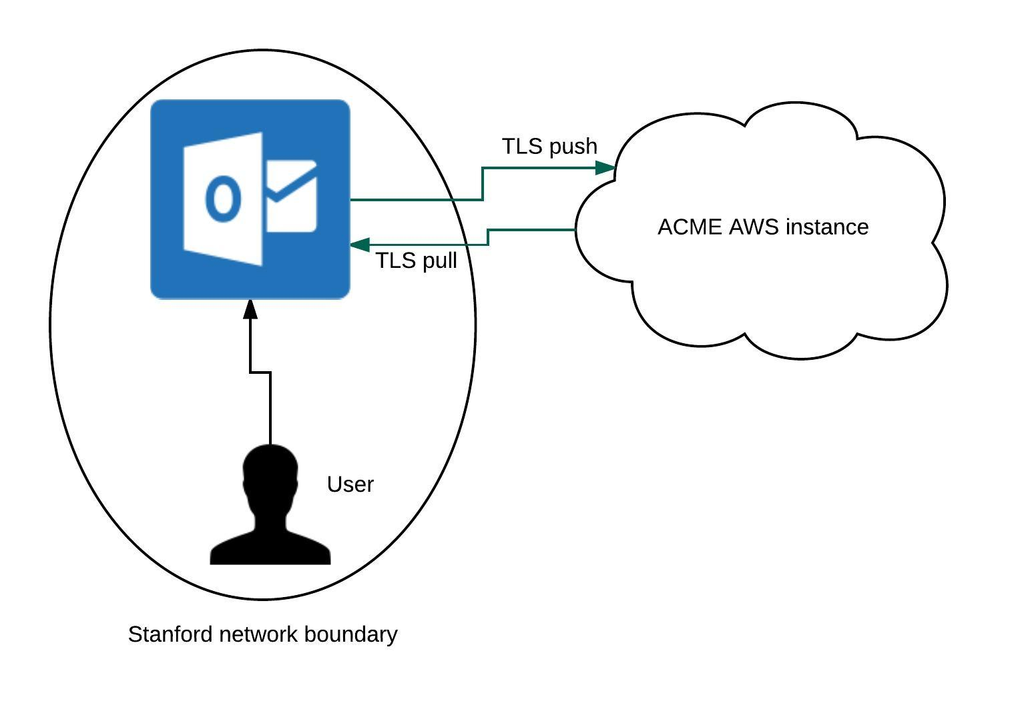

- Storage, Retention and Destruction. Provide a data flow description for each stage of the data lifecycle (collection, storage, use, transmission, access, and destruction).
When a user enters information into the “Location:” section of Outlook, conference room availability data will be sent to ACME via Outlook. Conference room data is “pushed” from Outlook to ACME which then aggregates data and sends it back to the user to select an available conference room. Once a user selects a conference room, that same data will be pushed back to ACME to label that same conference room as “unavailable” to other users.

The user can select and book any available room using their SUNet ID and email address. ACME does not see or process any other information about the purpose of the meeting or the attendees. It would just know that John Doe booked Conference Room A from 8-9am on January 1, 2016, for example. The availability data and the booking specifics are stored by ACME for 30 days after the date and then destroyed. ACME may use the data internally for process improvement. Their privacy and security practices, including when they disclose data outside of ACME, are explained on their website at privacy.ACME.com.

Dataflow diagram is attached in HelpSU ticket as well as this document.
Data is stored in ACME’s AWS instance and will be exchanged with Stanford’s Outlook servers.
Data is transmitted via encrypted link. Data is accessible only by Stanford staff/faculty and an Outlook account.
UIT Communications would like more details on data destruction from ISO and Privacy.

- Data in Transit.
- What protocols are supported and enabled to transmit application encrypted data? Select all that apply.

☒ TLS 1.1 ☐ TLS 1.2 ☐ Other (specify):

- Is Stanford initiating the transmission? ☒ Yes ☐ No
- Is Stanford pushing or pulling data from other vendor systems? ☐ Pushing ☐ Pulling ☒ Both

- Data at Rest
- Is data encrypted at rest? ☐ Yes ☒ No
- Are backups encrypted? ☐ Yes ☒ No
- Describe how encryption keys are being secured, including who has access to the keys.
As data is not encrypted at rest, there are no encryption keys.

- Access.
- Users and Administrators. Identify the individuals, or classes of individuals, and their roles who will have administrator access and who will have user access to the system. Specify who manages access.
Only SU personnel will have admin access rights to the account.

- User Methods. Check the different methods by which the users can access the system
☐ SSH ☐ Web Application ☒ Client Application
☐ Other (specify)
Data will not be directly accessibile by users, except via outlook clinet.

- Admin Methods. Check the different methods by which the administrators can access the system
☐ SSH ☒ Web Application ☐ Client Application
☐ Other (specify)

