
Unanet optimizes your work!

Unanet Project Portfolio Version 9.0

Sample Screens, Tools and Reports
45240 Business Court, Suite 200 – Sterling, VA 20166 USA – (703) 689-9440 – www.unanet.com

Unanet 9.0 Project Portfolio Sample Screens, Tools and Reports

Contents:

- Personal Dashboards to provide visual insight on key performance indicators
- Profitability Drill Down Graph & Results of Drill Down from Profitability Graph
- Project Actuals Summary Chart
- Resource Allocation Chart
- Resource Allocation/Utilization Report
- Project Performance Report (Actual-To-Budget)
- Earned Value Cumulative Chart
- Earned Value Management – Schedule and Cost Performance
- Gantt Chart
- Margin/Profitability Report
- Project Billable Report
- Client and Project Status Report
- Revenue Recognition
- Project/People Matrix Report
- Summary Revenue Forecast by Project
- Project Plan Summary
- Grid Planner
- Matrix Planner
- People Periodic Forecast Report
- People Schedule Details Report
- People Forecast Report
- Actuals (Labor and Expense) Summary Report
- Timesheet Status Chart and Report
24. People Accrual Details Report

1. Personal Dashboards to provide visual insight on key performance indicators – each user can configure their system to deliver, in one place, a set of graphical charts showing just the metrics they need on the projects and people of interest. The typical example shows some of the different charts available in Unanet. Each chart provides drill-down to more detailed information.
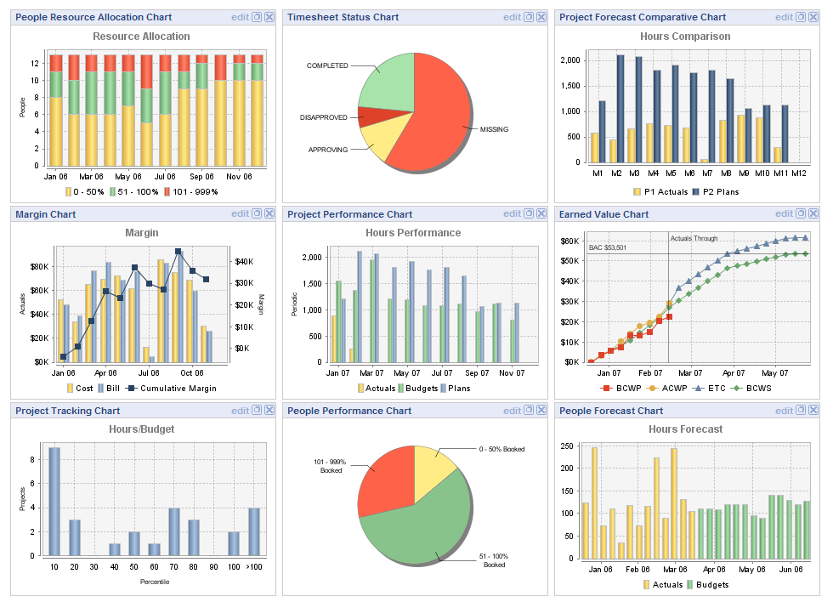
2. Profitability Drill Down Graph – The following report depicts margin over time. Clicking into the graph shows the details of a specific period.
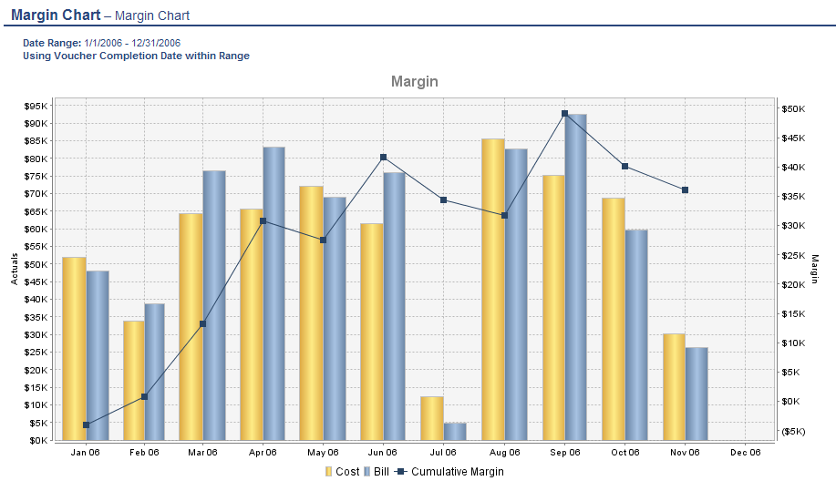

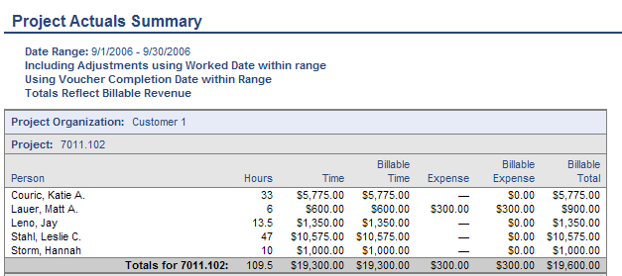
3. Project Actuals Summary Chart – The following chart depicts billable charges for the largest five project organizations. Report selection criteria allow any number of projects or organizational groups to be shown, and costs, charges or hours displayed. Clicking into the piechart shows the details of a specific organization, in this example.

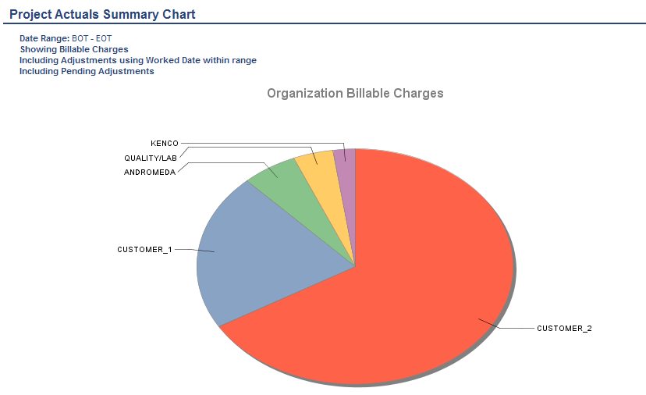

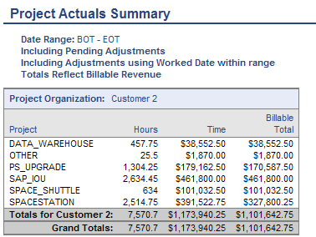
4. Resource Allocation Chart – This shows a summary of current resource allocation for a specified time period, with color coding to highlight capacity and overloading. Clicking on this chart provides detail information from the Resource Allocation Report shown on the next page.
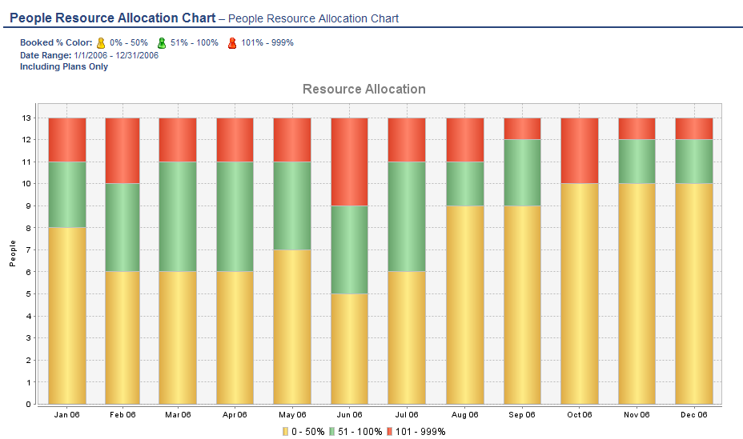
5. Resource Allocation/Utilization Report – This shows, by region, current resource allocation, both actual and planned, as well as future capacity to take on new work. A second example displaying weekly utilization is also shown.
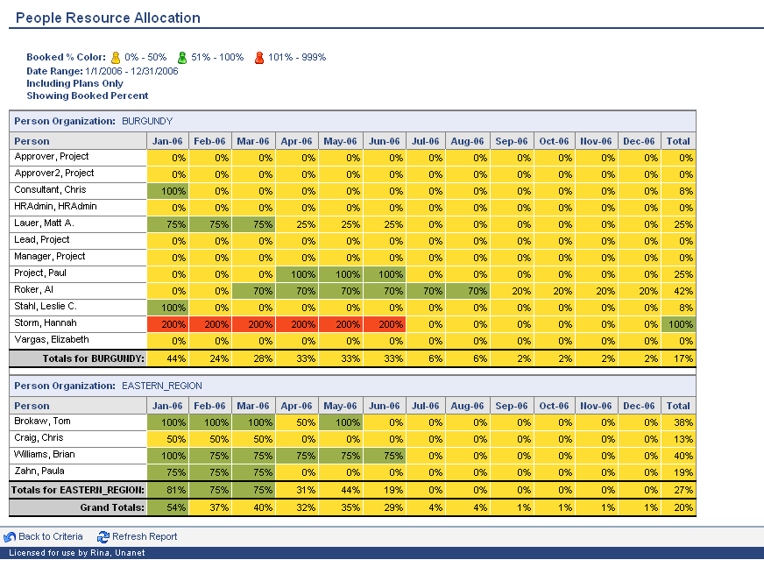

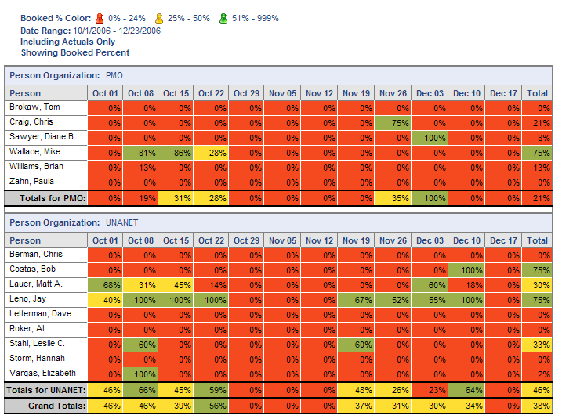
6. Project Performance Report (Actual-To-Budget) – The following version displays total actual costs vs. budgeted labor costs by project for three customers, and then a drill down for one project by task and person.
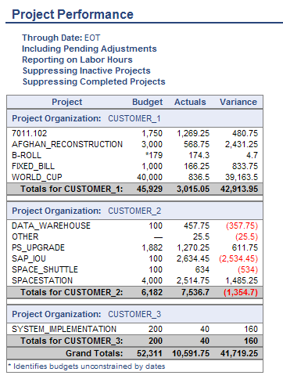

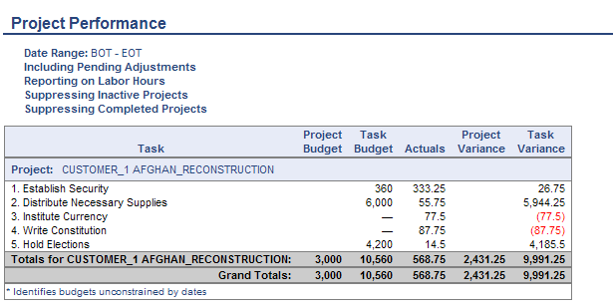
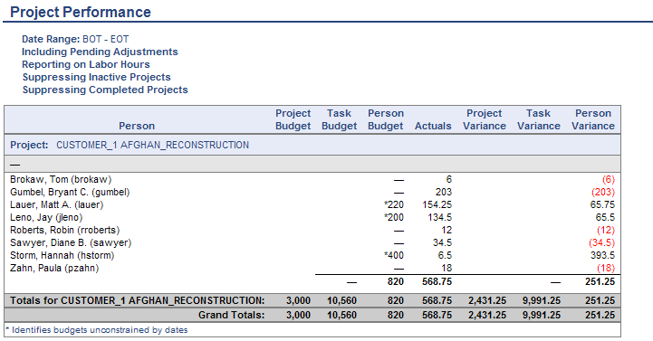
7. Earned Value Management - For one project, cumulative cost and schedule performance is shown, including Earned Value (BCWP) and Estimate To Complete based on performance to date on the project.

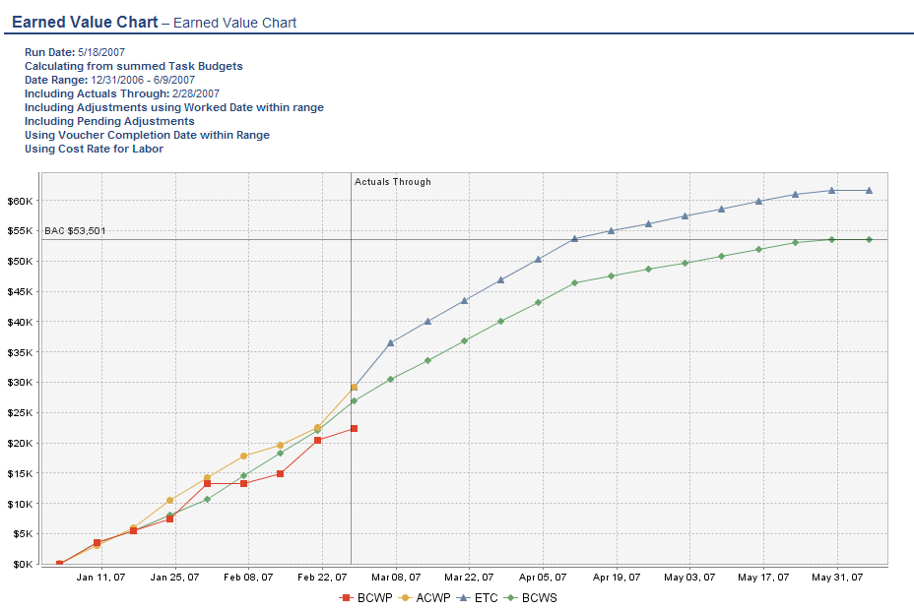
8. Earned Value Management – Schedule and Cost Performance - For one customer, cost and schedule performance across five projects is shown using the earned value analysis method.
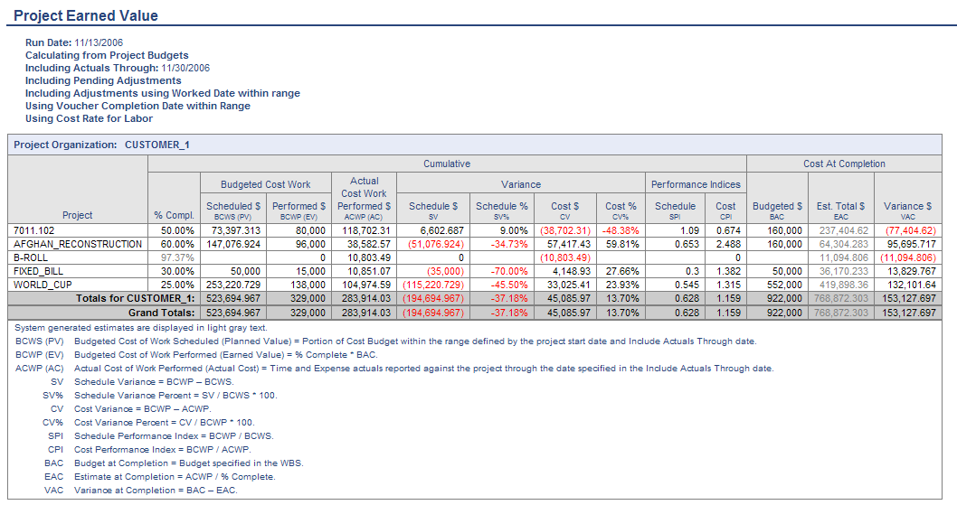

9. Gantt Chart – The following report shows the Gantt chart for tasks on a project.

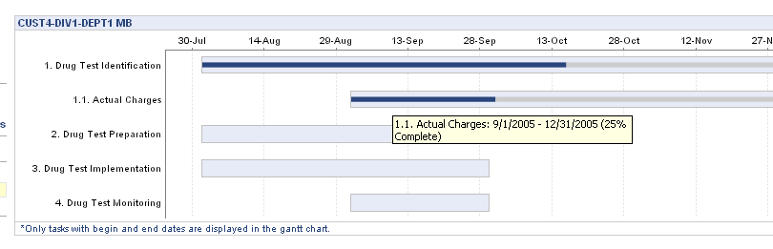

10. Margin/Profitability Report – The following version displays margins and profitability by person and project for Project PS_UPGRADE for Customer 2, and then a drill down to look at a specific task.
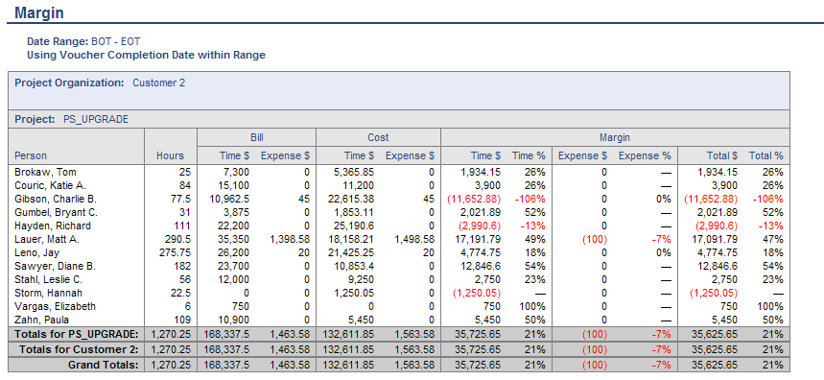

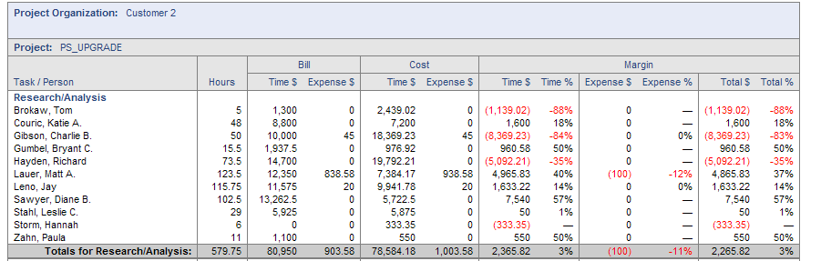
11. Project Billable Report - The following reports display billable labor and expense across all projects, and then details for a customer invoice, and a further drilldown shows this information rolled up to summary tasks with detail at the second level of the Work Breakdown Structure (WBS).
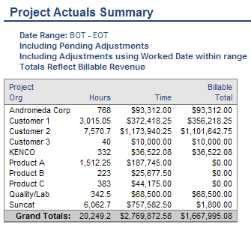
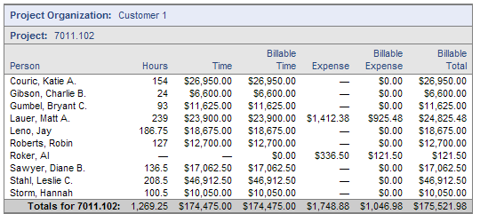

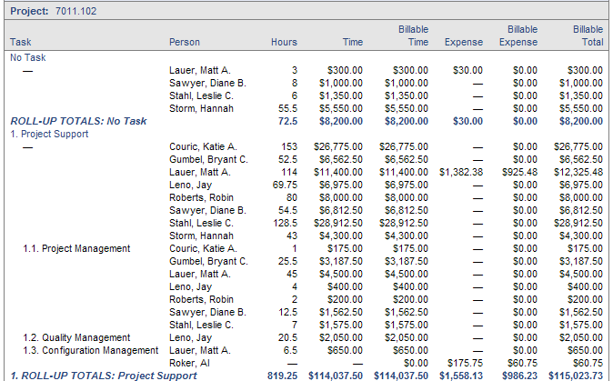
12. Client and Project Status Report – The following report displays the status of active billable projects for Customer 3. This report shows project status with qualitative and quantitative information.
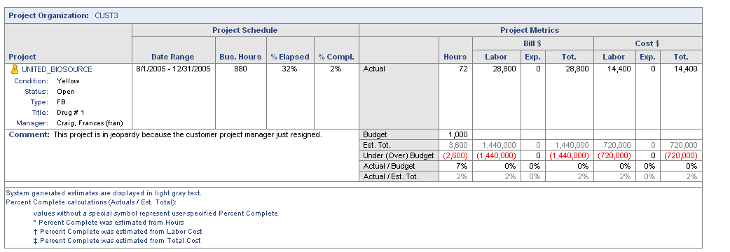

13. Revenue Recognition – The following report shows the revenue recognition supported by process workflow.

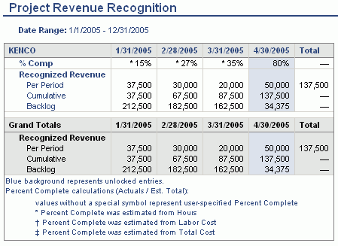

14. Project/People Matrix Report – The following report displays actual hours or money amounts by people (columns) and by projects (rows). Shown below is a similar People Matrix Report showing hours or amounts by projects (columns) and by people (rows).
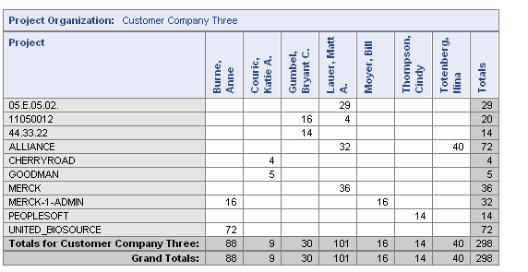

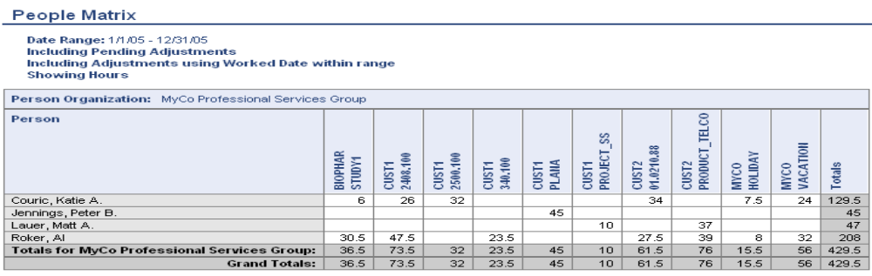
15. Summary Revenue Forecast by Project – The following version displays expected revenue generated from Customer 2’s projects. Actual booked revenue can be displayed through today’s date with forecasted revenue through end of reporting period.

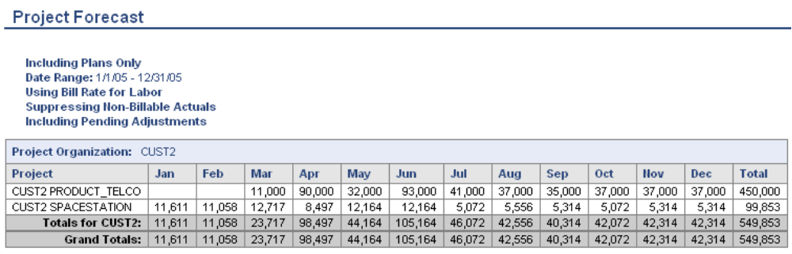

16. Project Plan Summary - The following report displays a status of planned hours vs. budgeted hours vs. actual hours. Key metrics on project performance vs. budgets and plans are displayed.
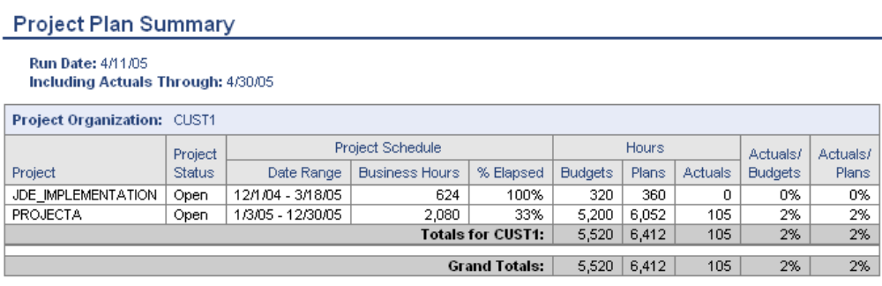

17. Grid Planner – The following tool enables planning in a spreadsheet-like grid for people over months or weeks on one project.

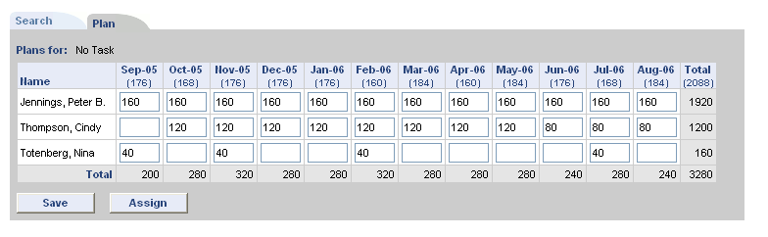

18. Matrix Planner – The following tool enables planning in a spreadsheet-like grid for people over multiple projects for one quarter, one month or one week.
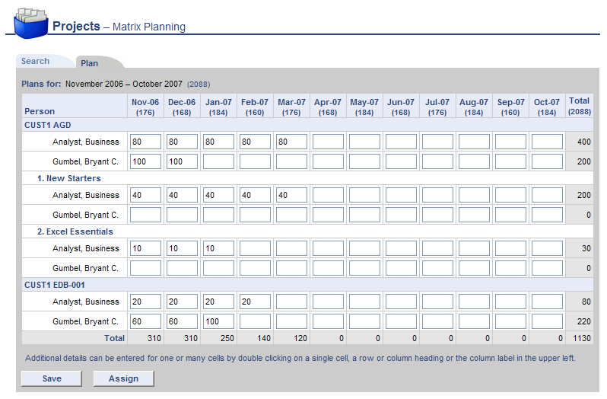

19. People Periodic Forecast Report - This displays a forecast of People, Projects and FTEs. The report can optionally be run to show cost or revenue information in a Weekly, Monthly or Quarterly layout.
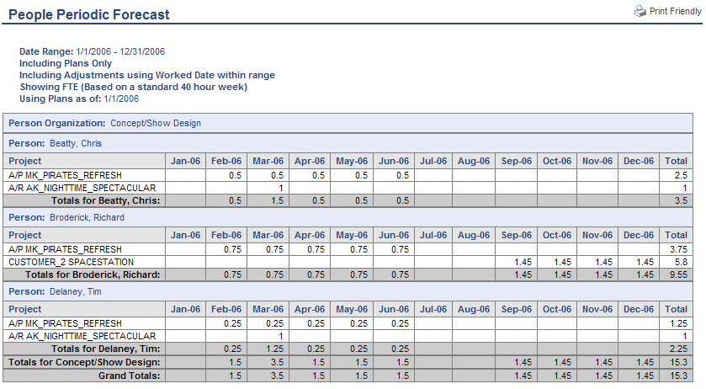

20. People Schedule Details Report – The following version displays a list of ‘plans’ – scheduled hours per project - for 2 users for one year.
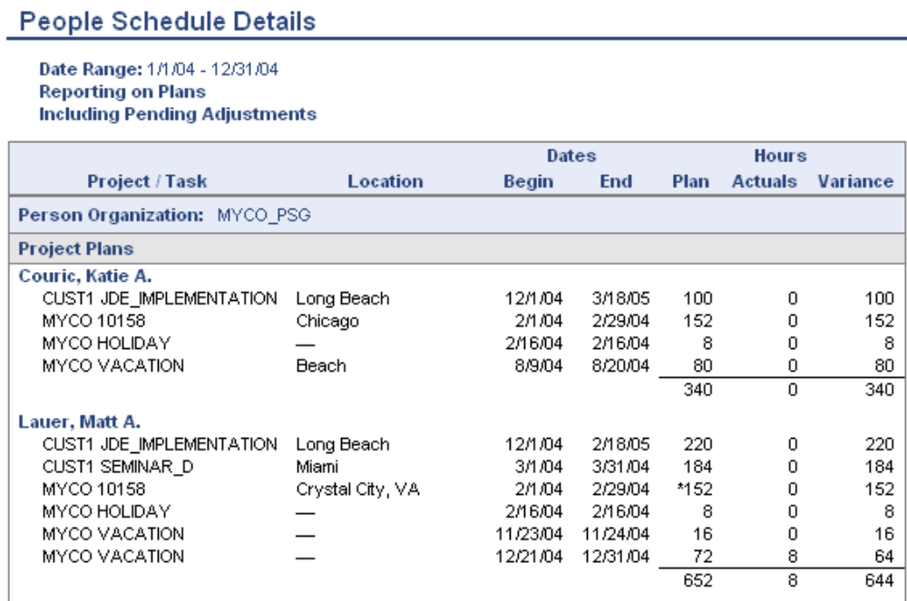

21. Project Periodic Performance Analysis – This report shows soft-booking (plans), hard bookings (budgets) and actuals.

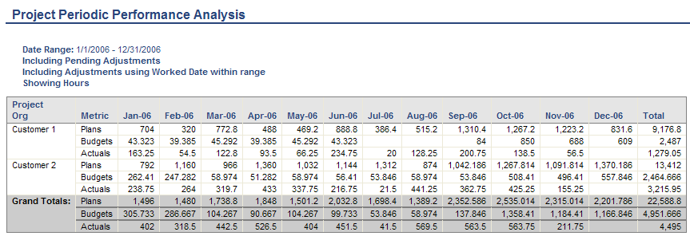
22. Actuals (Labor and Expense) Summary Report – The following report displays total billable labor and expense summarized by organization. The second report shows a drill down to the person level for one organization, Suncat.
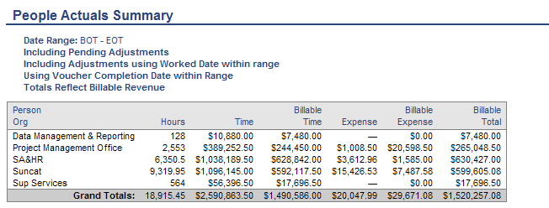

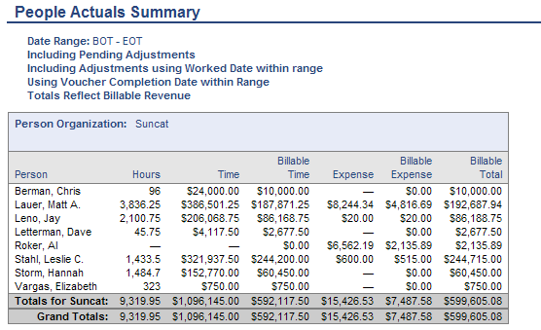
23. Timesheet Status Chart and Report – These reports shows the a summary pie-chart of status of timesheets for a period and then a drill-down by status into the hours completed by an individual, the number of hours an individual has recorded, and based on each user's Business Week definition, the percentage of hours completed thus far for a given time period. The report also shows Pending Manager Approvers, Project Approvers and Customer Approvers.
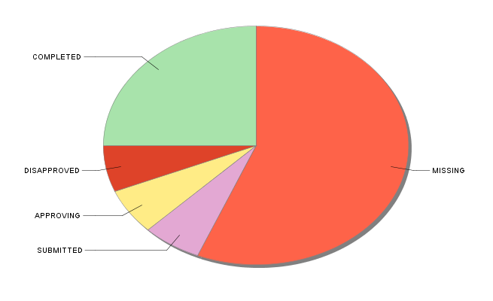
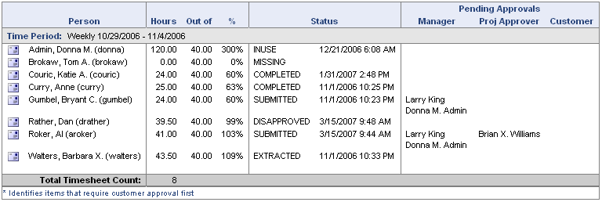
This report can be directed to provide a summary of status information as well as provide the detailed preview versions of each timesheet. Further, this report can optionally include Time Adjustment details or have those details suppressed in order to provide an original timesheet view (i.e. the originally LOCKED or EXTRACTED timesheet prior to any adjustments being applied).
24. People Accrual Details Report – This report provides a detailed view of a person, or persons, accrued time details.



